|  |
| --- |
| 新东方在线英语学习 |
| 新概念 1 册 |
| Lesson45-46 |



扫一扫。更多有趣的英语资讯。

# Lesson 45 单词讲解

1. can: 能够、可以
2. boss: 老板

manager, 经理mai ni zhi er

1. minute: 分钟\ 一会儿mai nei te

Wait a minute. 等一会，等一下小时: hour，ai wo er 秒钟: second

1. ask: 请求\ 问

Can I ask you a question? ask the way 问路

1. handwriting: 书写righting
2. 他的字写的很好。

His handwriting is very nice.

1. terrible : 糟糕的

It’s terrible today.

# Lesson 45 课文讲解

1. Can you come here a minute please? a minute: 一会、一下
2. next door 在隔壁＼与…相邻

She is next door. 她在隔壁。

She is next door to us. 她与我们相邻。There is a school next door to the park. 公园的隔壁有所学校。

next-door adj. 隔壁的

The next-door girl is very beautiful. 隔壁的女孩很漂亮。

The old man next-door is going to leave.

隔壁的老人就要离开人世了。

# Lesson 45 语法讲解

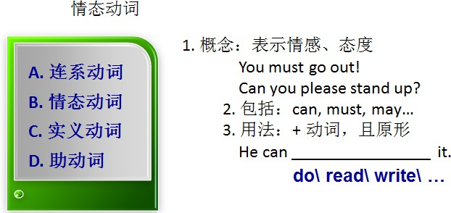

1. 没有人称和数的变化

She is… I am…

She can… I can…

He is… They are…

He can… They can…

1. 疑问句：提前
2. 否定句：can—can’t, cannot

must— mustn’t (禁止) may— may not

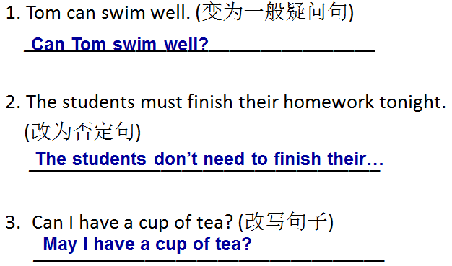

**Lesson 46 单词句型讲解**

1. lift: 举 起lai fu te

Can you lift this heavy case?

电梯（英式直梯，美式：elevator）

There are thirteen people in this lift, it’s overweight.

电梯里有 13 人，超重啦！

1. cake: 蛋糕，可数名词
2. biscuit: 饼干，可数名词bai si k te

# Lesson 45&46 知识拓展

can 在口语中

1. Can I help you?
2. Can’t wait!
3. I can’t help! 没法子！
4. Can you give me a hand? 可以出手帮忙吗？